PLANS AND ELEVATIONS
Pearson Edexcel - Tuesday 21 May 2019 - Paper 1 (Non-Calculator) Foundation Tier

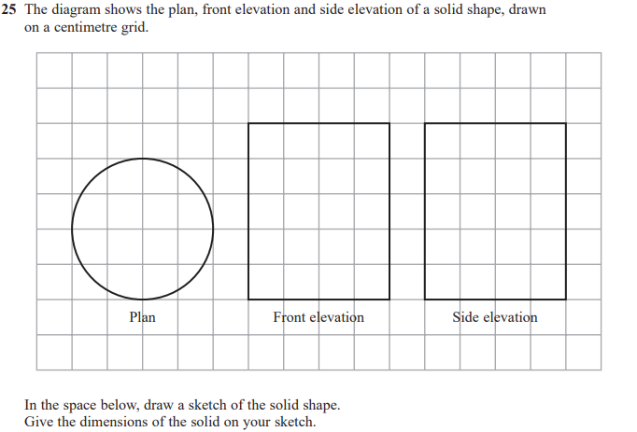
Pearson Edexcel - Thursday 24 May 2018 - Paper 1 (Non-Calculator) Foundation Tier

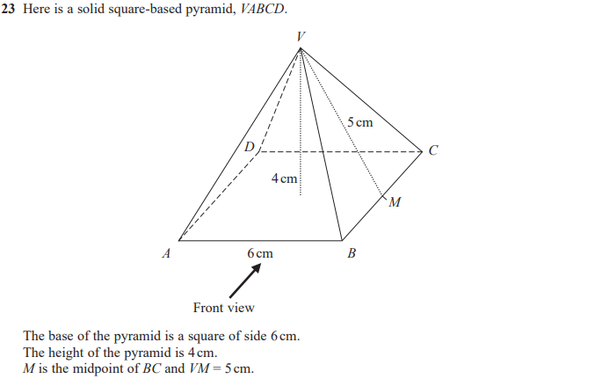
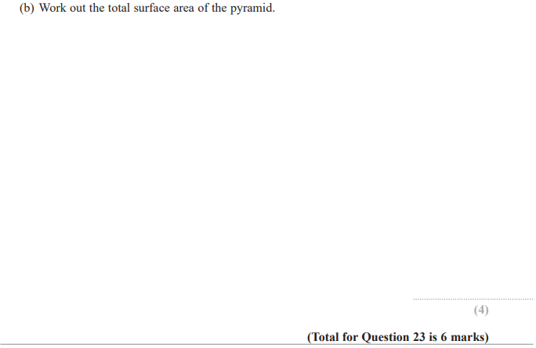

Pearson Edexcel – Specimen 2 - Paper 3 (Calculator) Foundation Tier

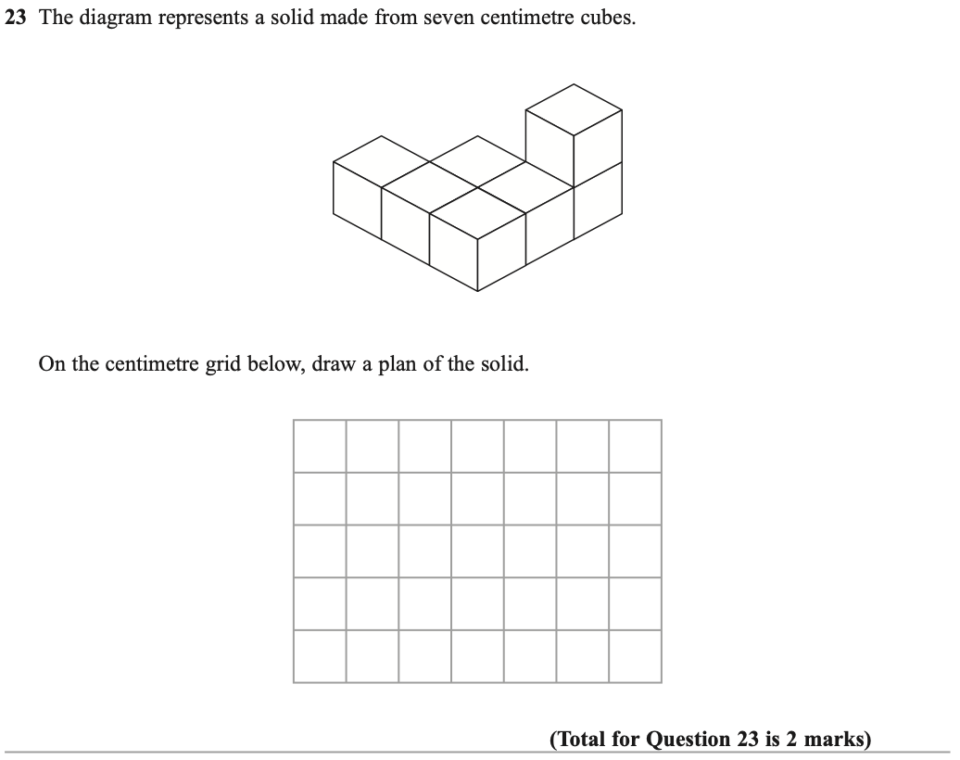

OCR November 09 November 2020- Morning (Calculator) Foundation Tier
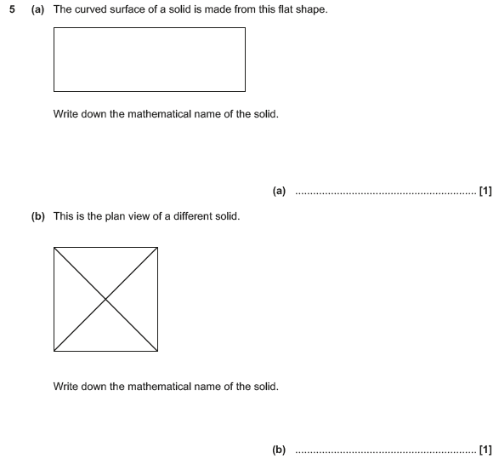

OCR Tuesday 11 June 2019 – Morning (Calculator) Foundation Tier
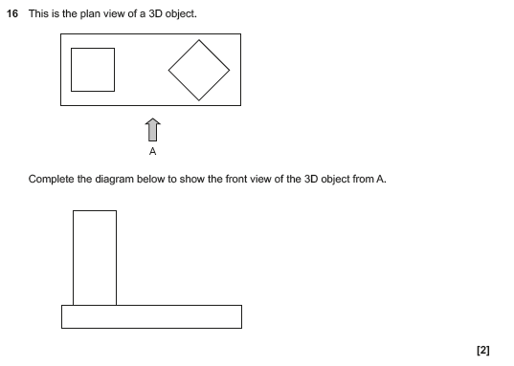

Pearson Edexcel – Sample Papers - Paper 1 (Non-Calculator) Foundation Tier

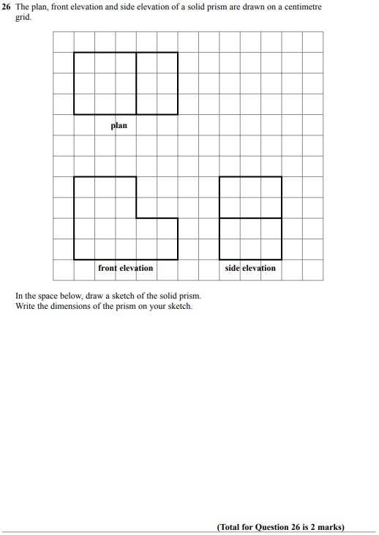

OCR Thursday 8 June 2017 – Morning (Non - Calculator) Foundation Tier

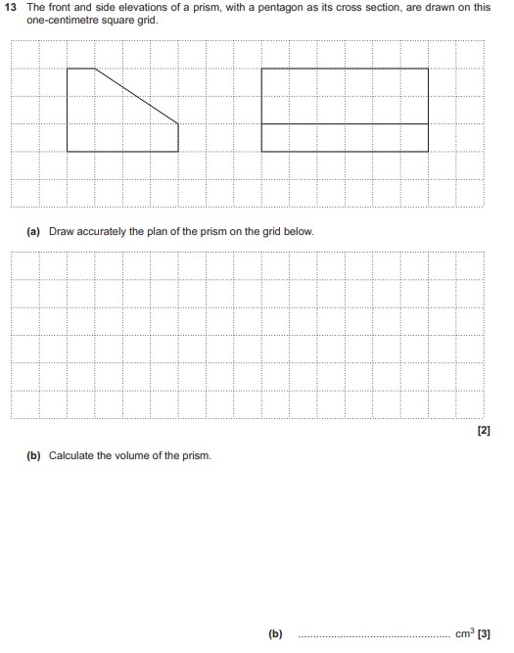

AQA Monday 8 June 2020 – Morning (Calculator) Foundation Tier

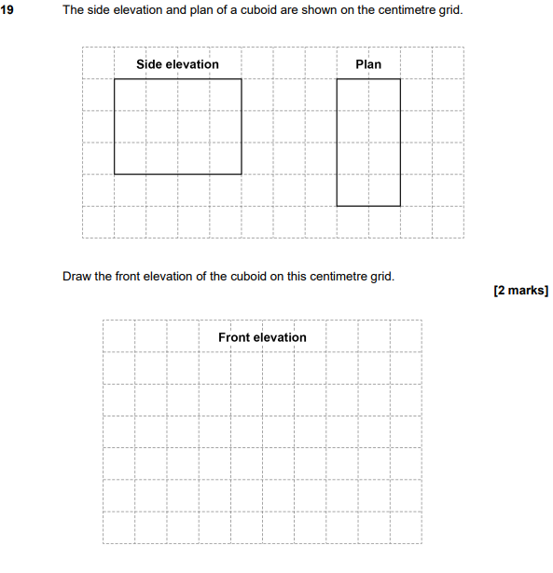

AQA Tuesday 21 May 2019 – Morning (Non-Calculator) Foundation Tier

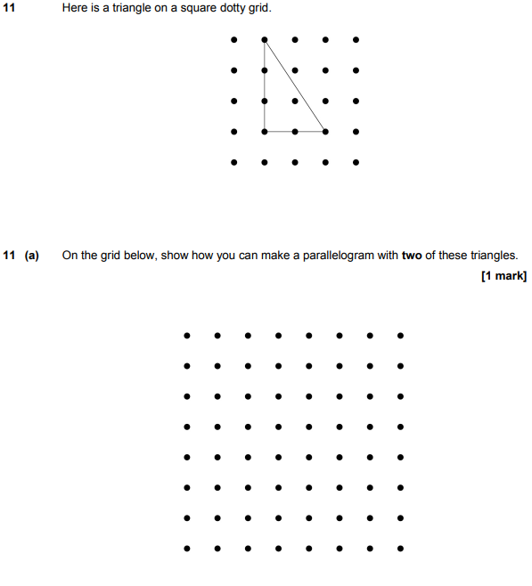

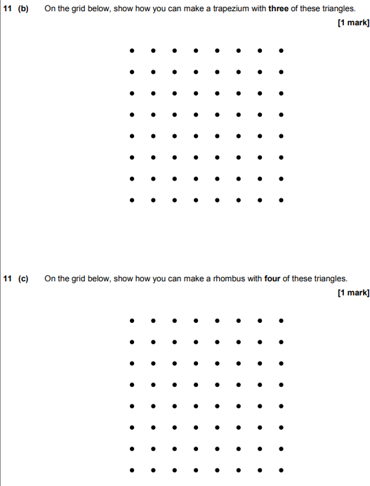

AQA Thursday 24 May 2018 – Morning (Non-Calculator) Foundation Tier

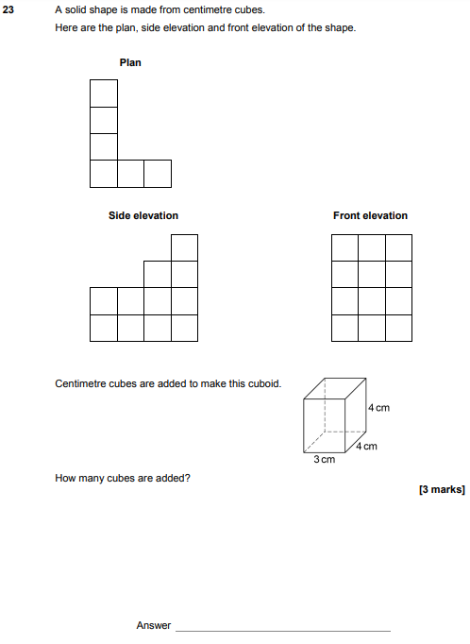

AQA Tuesday 13 June 2017 Morning– Morning (Calculator) Foundation Tier

